Erin Denning Final Project Screenshots

Main Screen

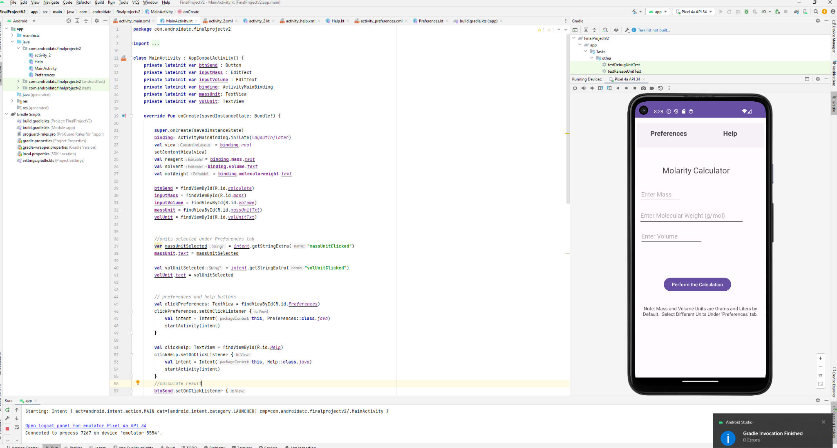

Help Activity

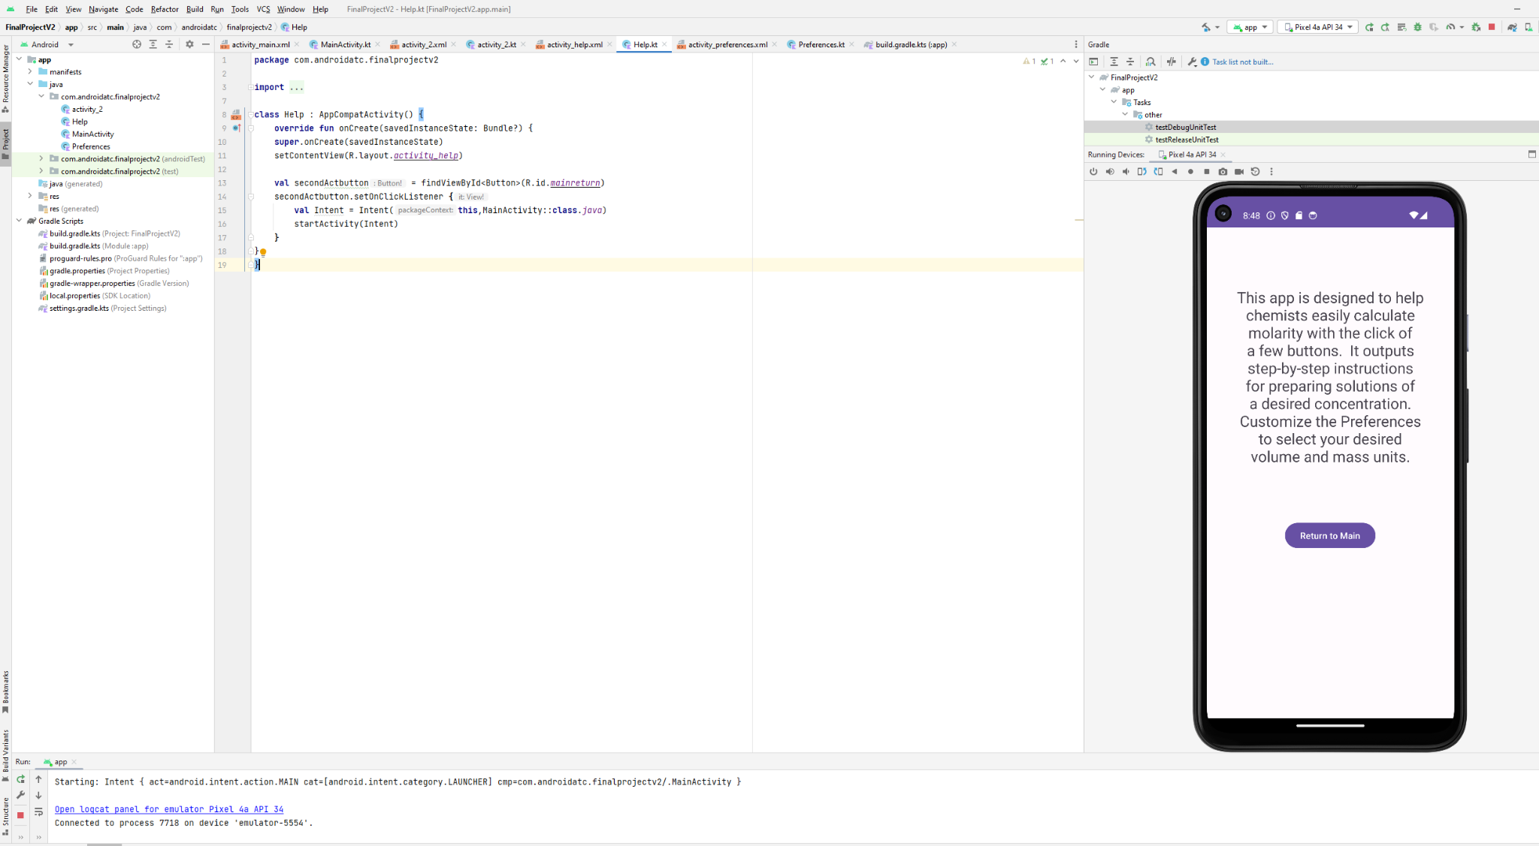

User selected Preferences options. Below, Grams and Liters are selected.

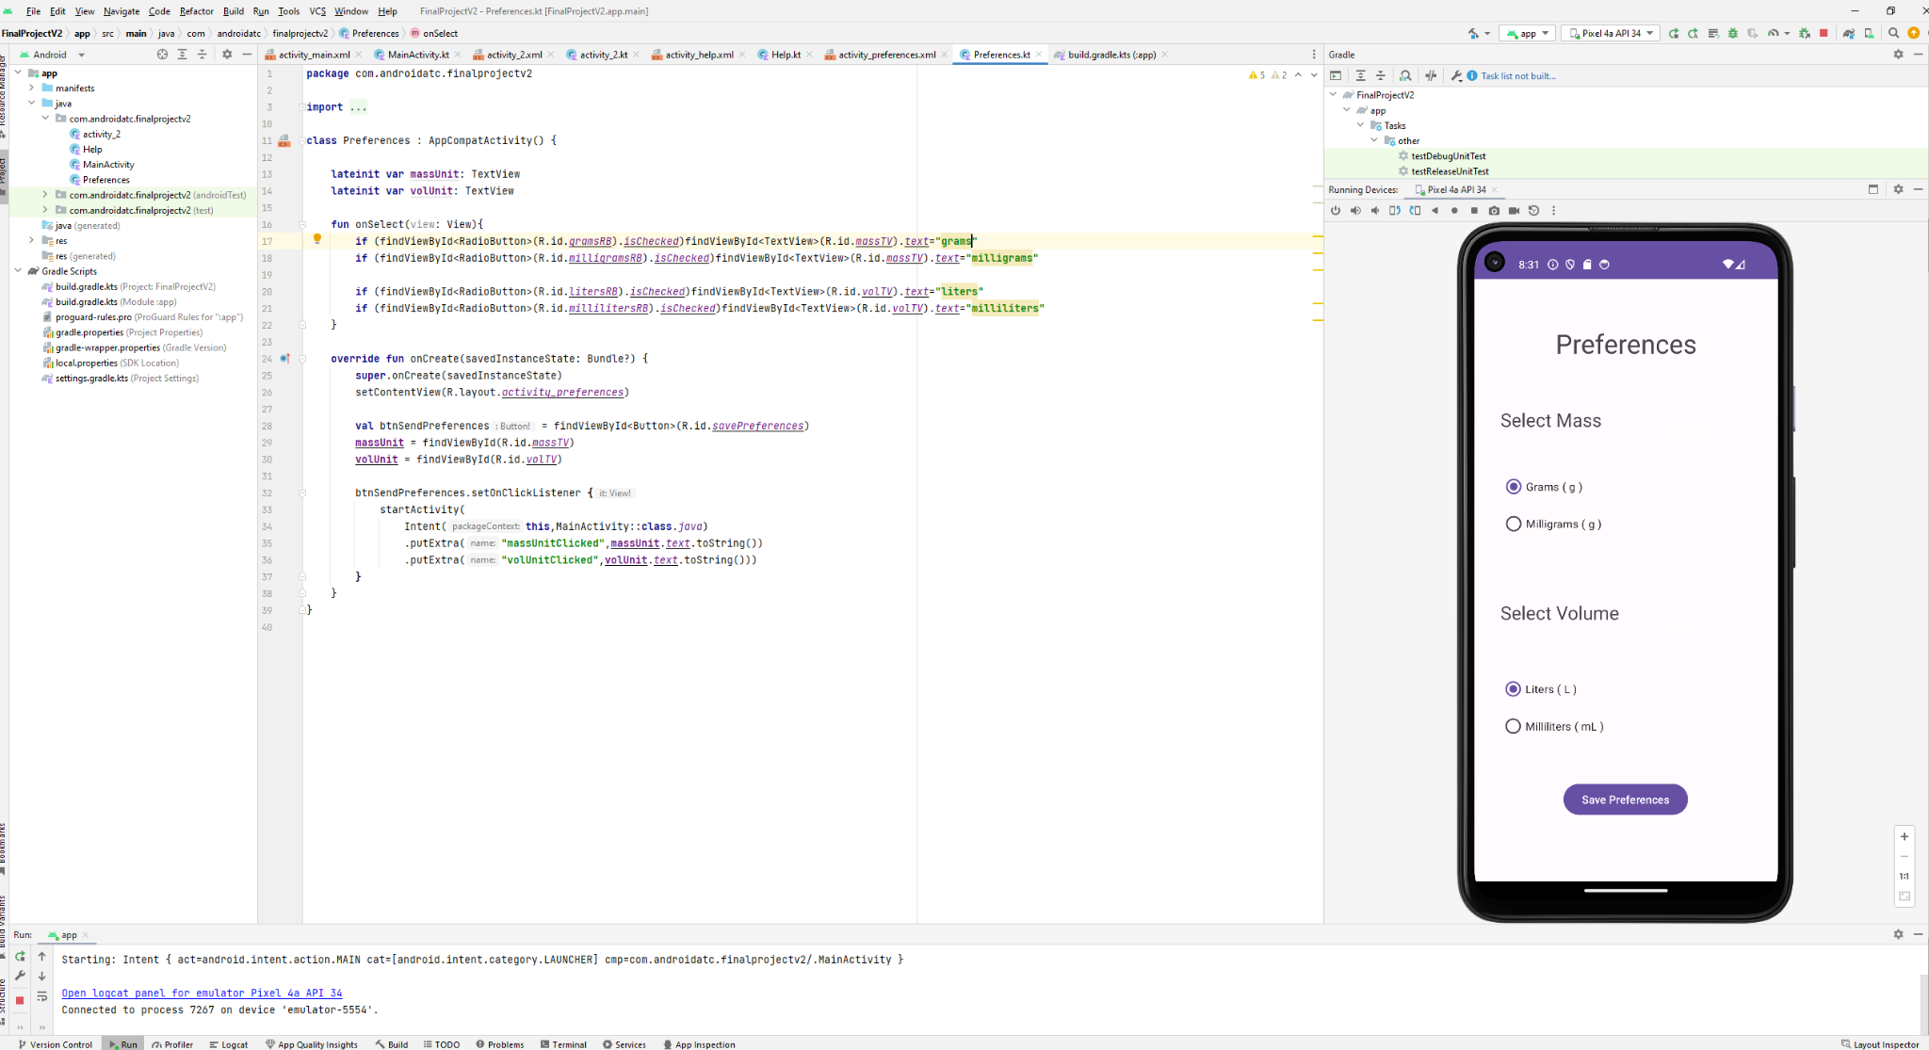

User Selected Preferences Now Display on the Main Screen

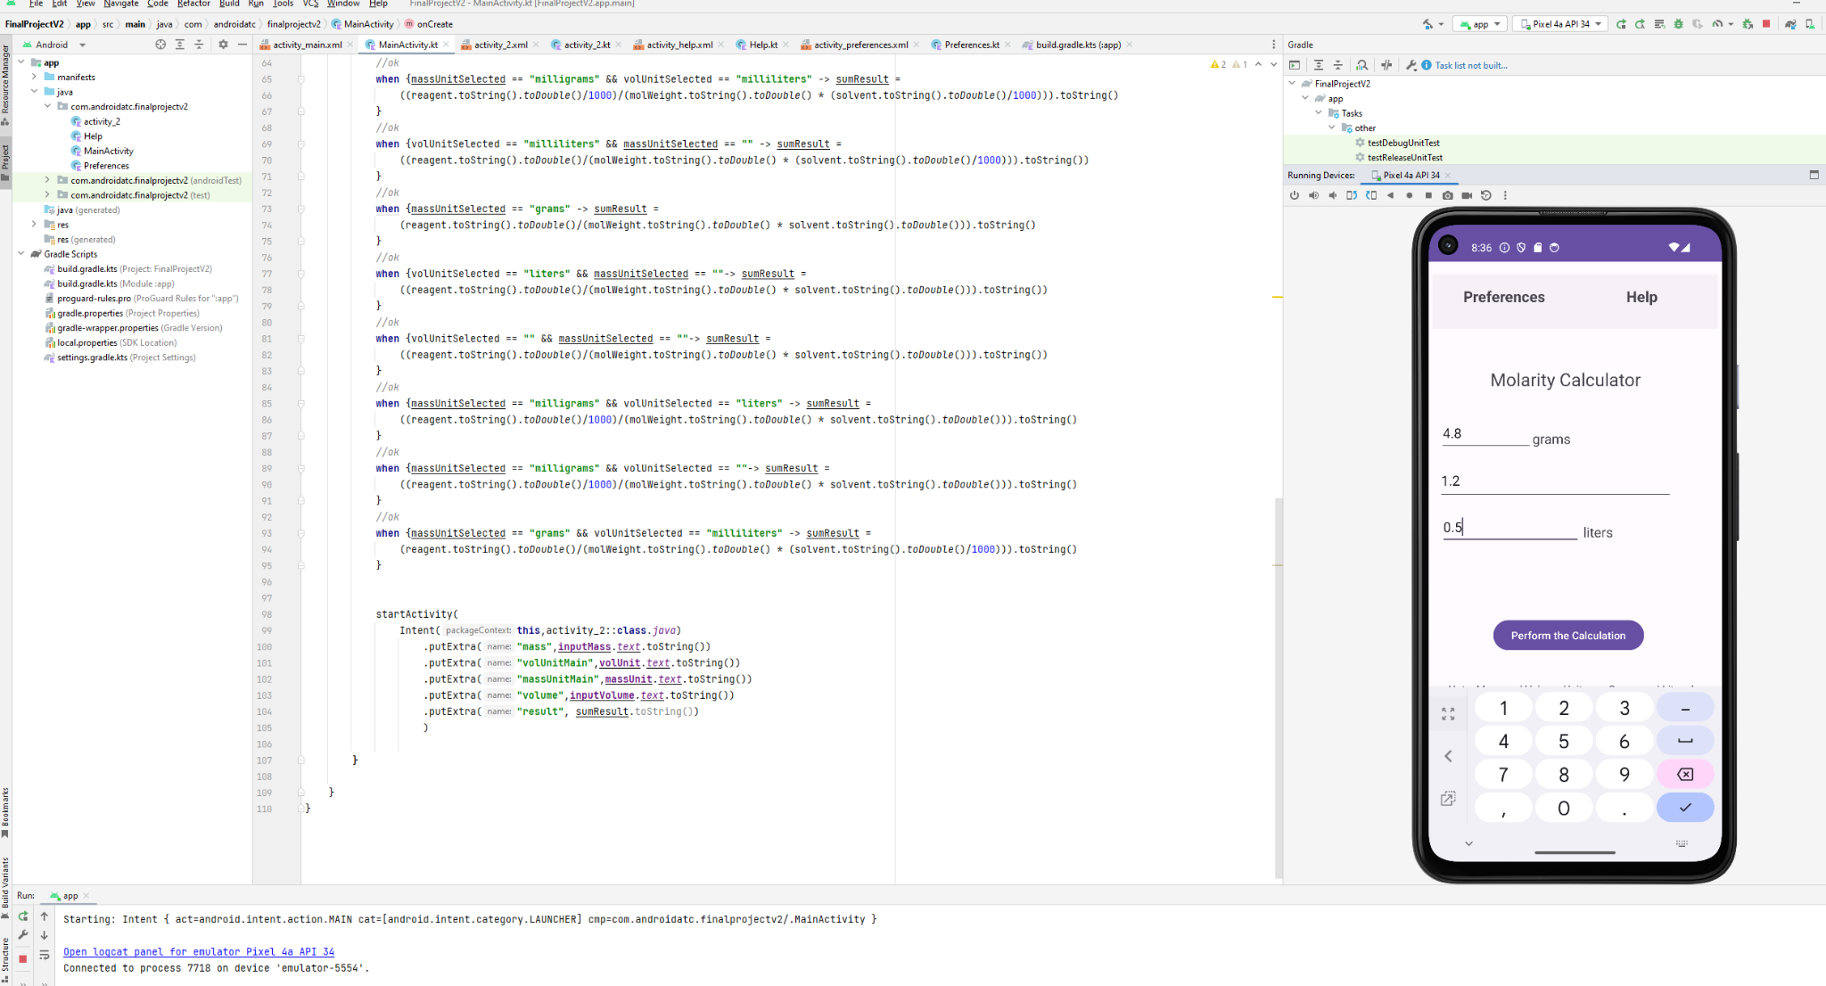

Correct output of results using Grams and Liters units. Units transfer to second activity as well.

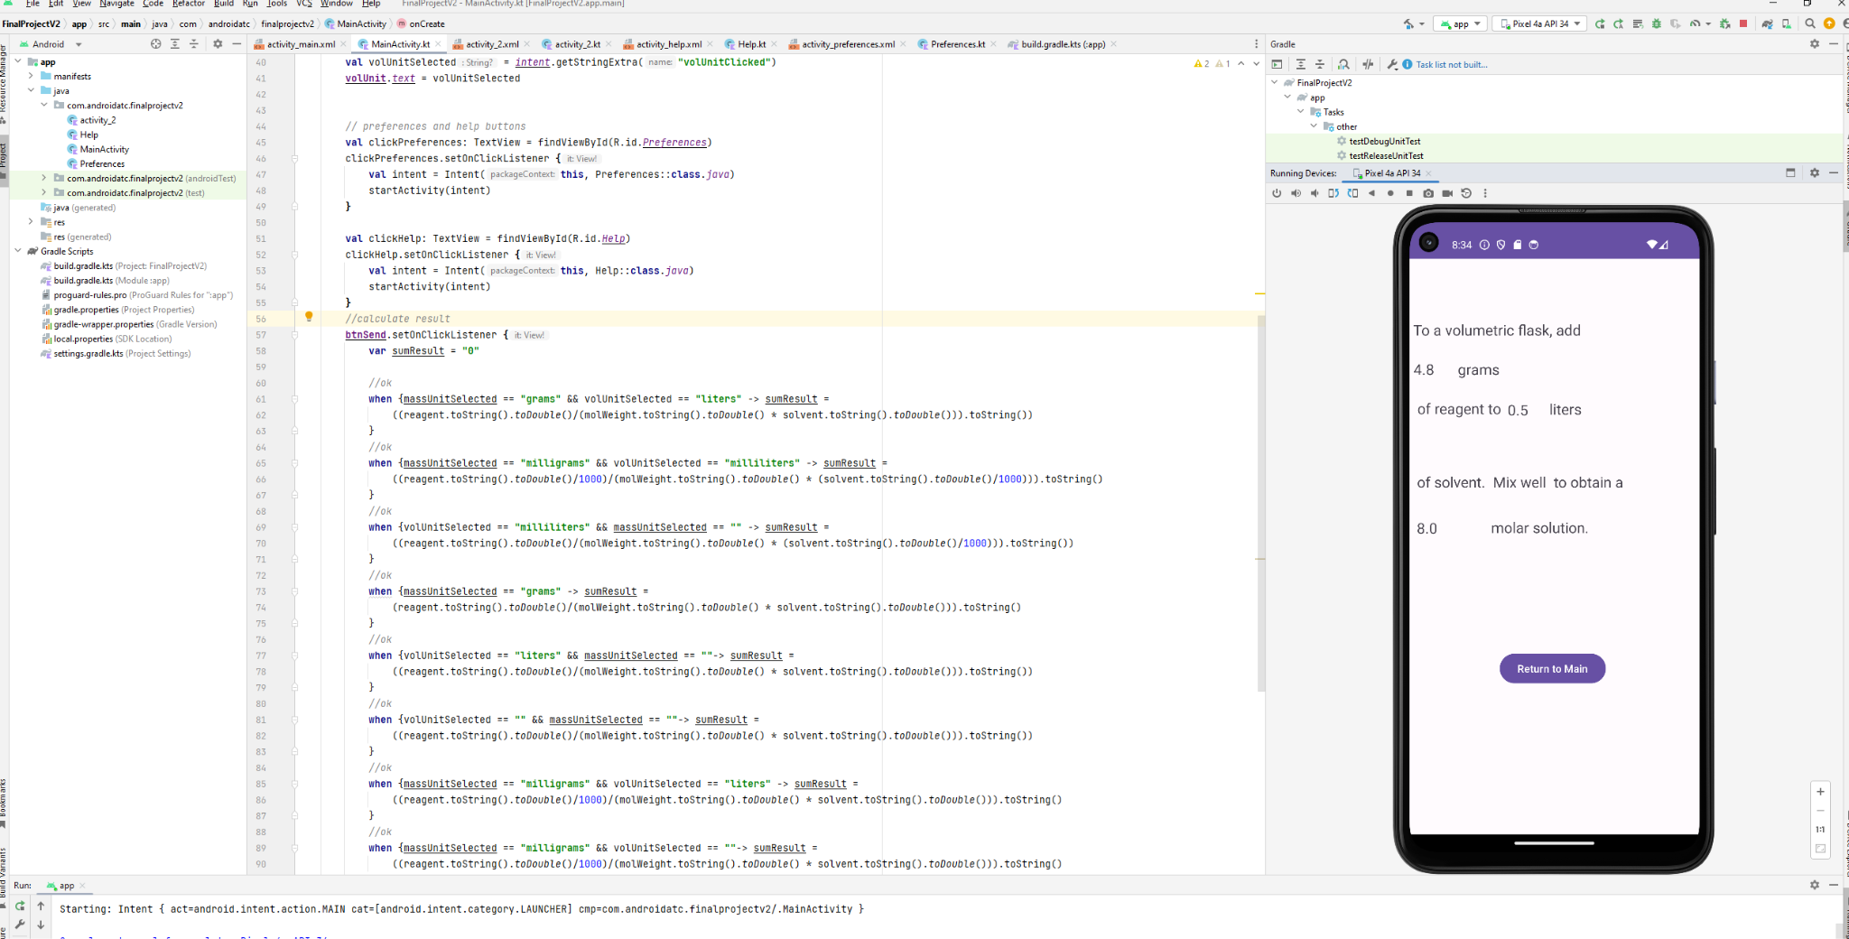

Milligrams and milliliters selected, plus coding for Preferences

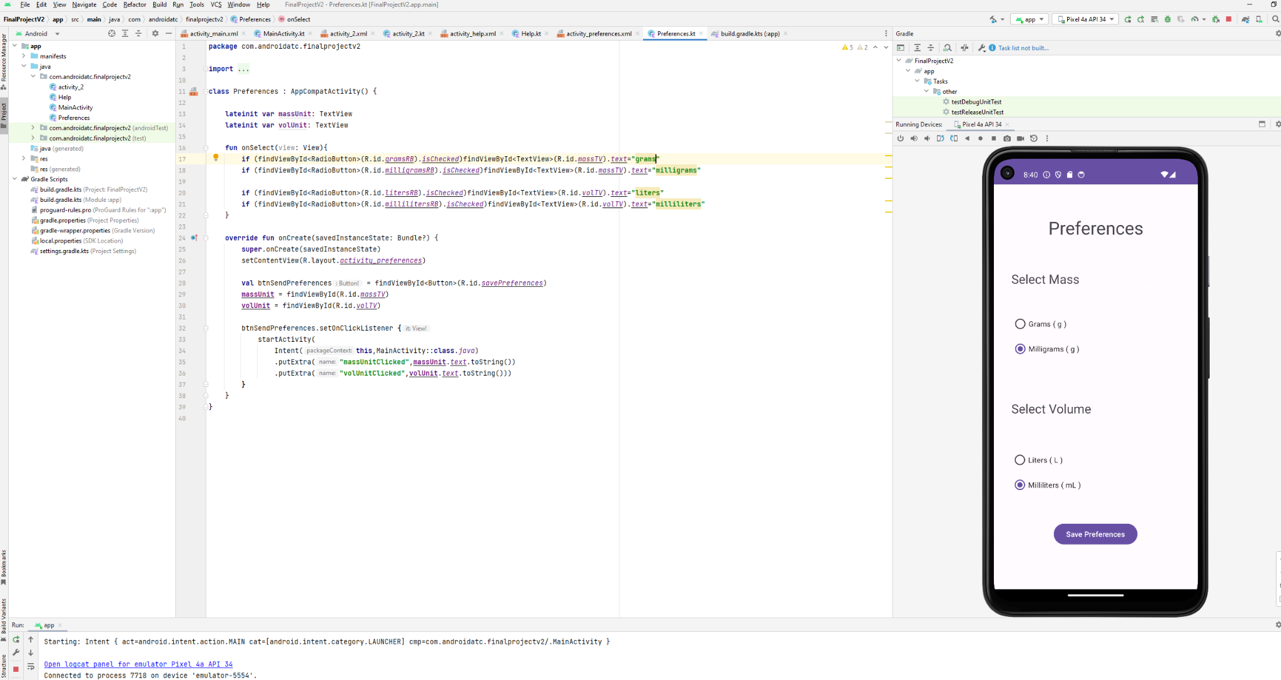

Milligrams and Milliliters Displayed on Main Activity

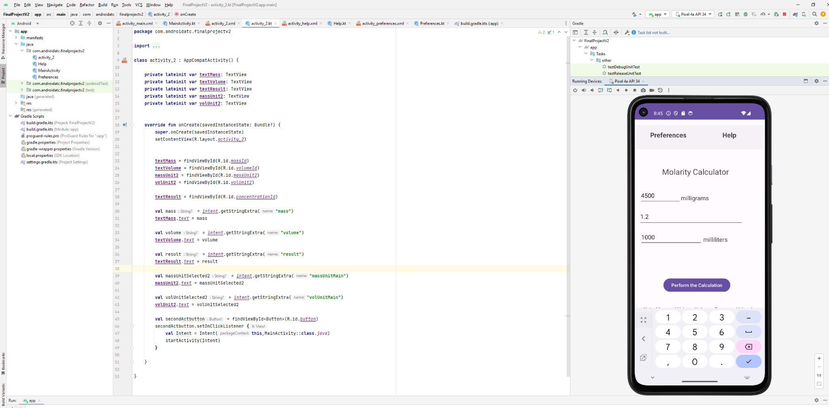

Results Plus Code for 2nd Activity

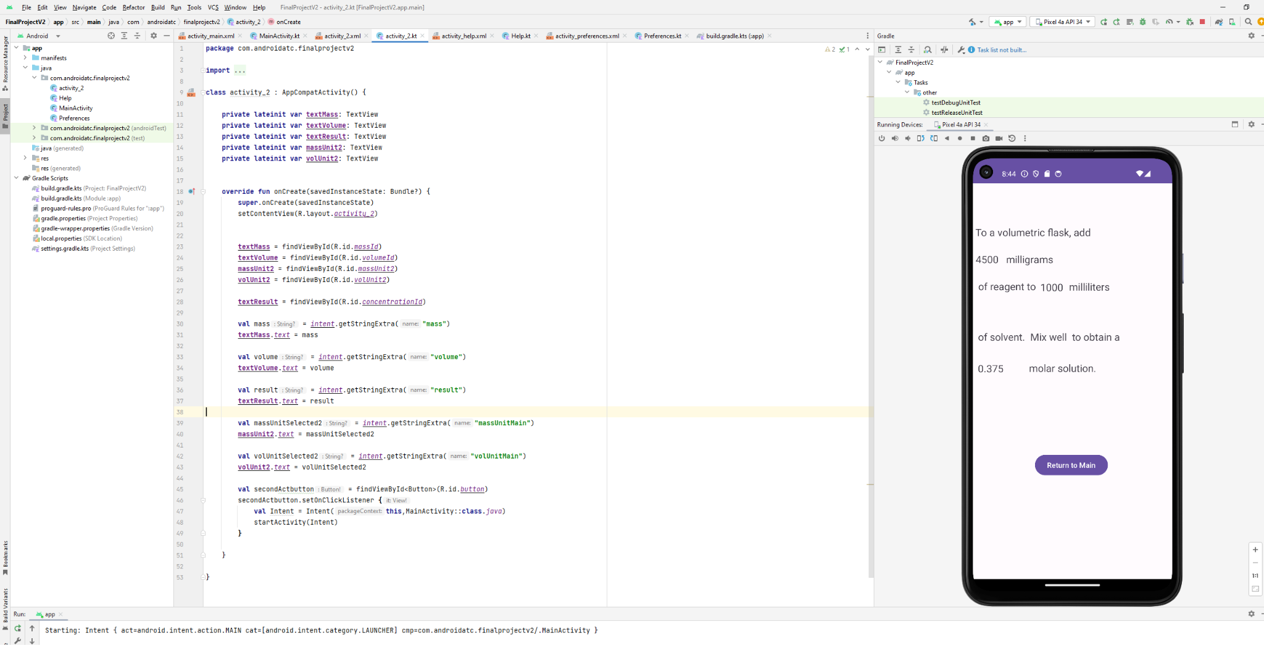

Mix of Grams + Milliliters also outputs correct calculation (next 2 images)

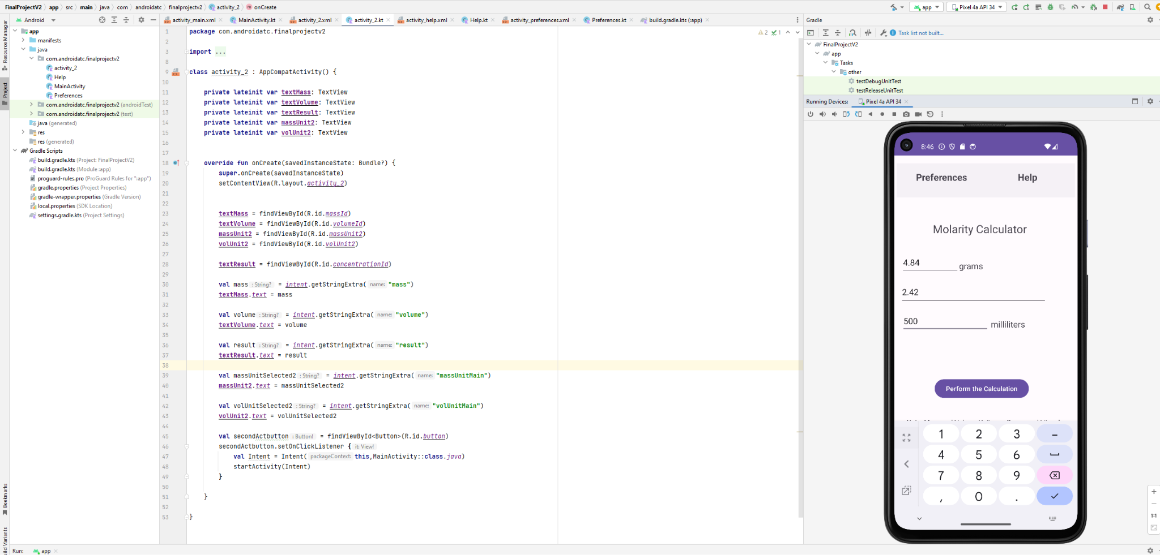

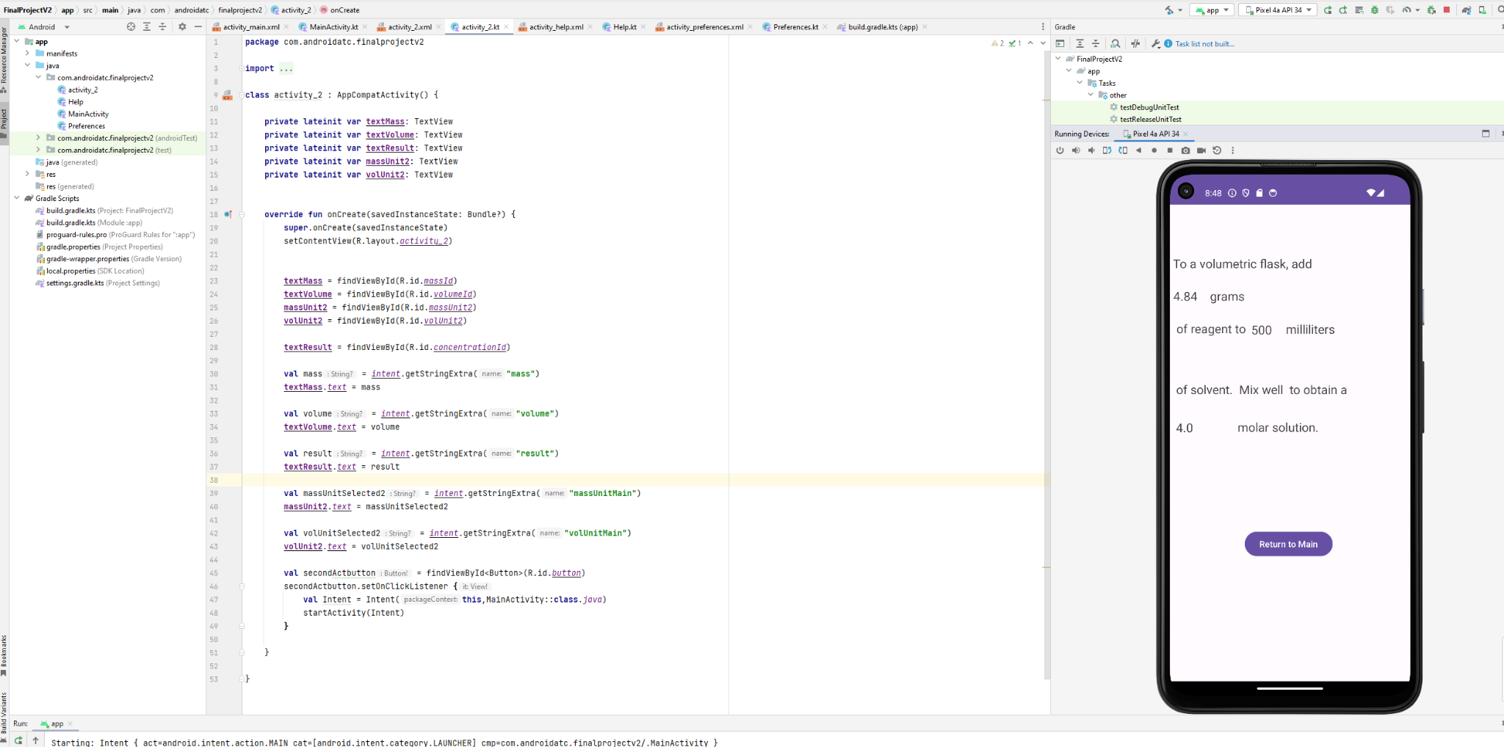

Mix of Milligrams and Liters Results (next 2 images)

